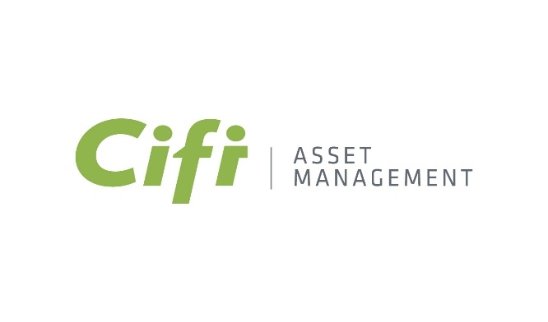

**CIFI Asset Management launches**

**the CIFI Sustainable Infrastructure Debt Fund**

* *CIFI AM closed the first phase of a new debt fund to invest in social and environmental infrastructure that protects the planet.*
* *This fund will be of three hundred million dollars (US$ 300 million). Its first closing amount was up to one hundred and thirty-eight million dollars (US$ 138 MM).*
* *The second phase of the fund contemplates up to one hundred and sixty-two million dollars (US$ 162 MM), offering the perfect opportunity to invest in profitable, sustainable development projects.*

At CIFI, we seek to generate a transformative and positive long-term impact for our clients, employees, investors, society, and the environment, while offering sustainable returns globally. That is why, through CIFI Asset Management (CIFI AM), in collaboration with development institutions, institutional investors, and private banks, we are introducing the CIFI SUSTAINABLE INFRASTRUCTURE DEBT FUND. This financial instrument channels resources toward developing sustainable infrastructure in Latin America and the Caribbean through safe and responsible investments.

This fund will have a total of US$300 million and a first successful closing of up to US$138 million. It focuses on sectors such as renewable energy, energy efficiency, sustainable tourism, health, education, logistics, and telecommunications, among others, within the social and environmental infrastructure*.*

**The CIFI SUSTAINABLE INFRASTRUCTURE DEBT FUND** is undoubtedly an impact fund. All the projects it includes will be developed under the highest environmental and social risk management standards, in line with the Paris Agreement and the SDGs. It aims to ensure a better planet and enable institutional investors and individuals through funds to contribute to infrastructure construction in the sectors, as mentioned earlier, while fostering economic growth and well-being in the communities where they are implemented.

Despite international agreements, such as the Paris Agreement, that seek to control industrial impact on the environment and establish concrete goals and actions to achieve the Sustainable Development Goals (SDGs) of the UN's 2030 Agenda, both business and personal involvement is necessary to implement measures to mitigate the impact of climate change.

The private sector is pivotal in driving regional growth, enhancing governments' work. For this reason, sustainable investments are a turning point in achieving economic and infrastructure development, representing a significant market opportunity for private investors.

According to the United Nations, robust financial resources and investments are required to address climate change, reduce emissions and promote adaptation to the already occurring impacts. The World Bank estimates a financing gap of $90 trillion by 2030, and private investment is crucial in closing this gap.

César Cañedo-Argüelles, CEO of CIFI, said: *“Thanks to CIFI's more than 20 years of experience in structuring loans for projects in the region, this new fund, which merges the vision of a group of investors and investment banking players, will be able to materialize sustainable projects that will transform thousands of lives*.

**About CIFI**

CIFI is the most experienced non-bank financial institution in infrastructure and energy financing in Latin America and the Caribbean. Since 2001, CIFI has analyzed more than 600 projects, participated in more than 200 transactions worth more than US$1.8 billion, and mobilized over US$20 billion in capital. CIFI has become a significant player in the trend toward sustainable infrastructure projects in Latin America and the region's overall economic development.

More information [www.cifi.com](http://www.cifi.com)

**Sobre CIFI AM**

CIFI AM (CIFI Asset Management) is an investment firm focused on debt financing of private middle-market infrastructure projects in Latin America and the Caribbean. As CIFI's asset management subsidiary, it provides diversified portfolio management services to institutional investors in infrastructure lending in areas of high population growth while mitigating environmental, social, and governance ("ESG") risks.

CIFI and CIFI AM adhere to the Equator Principles and the IFC Performance Standards.

More information [www.cifiam.com](http://www.cifiam.com)